APPENDIX B  Academic Systems & Processes  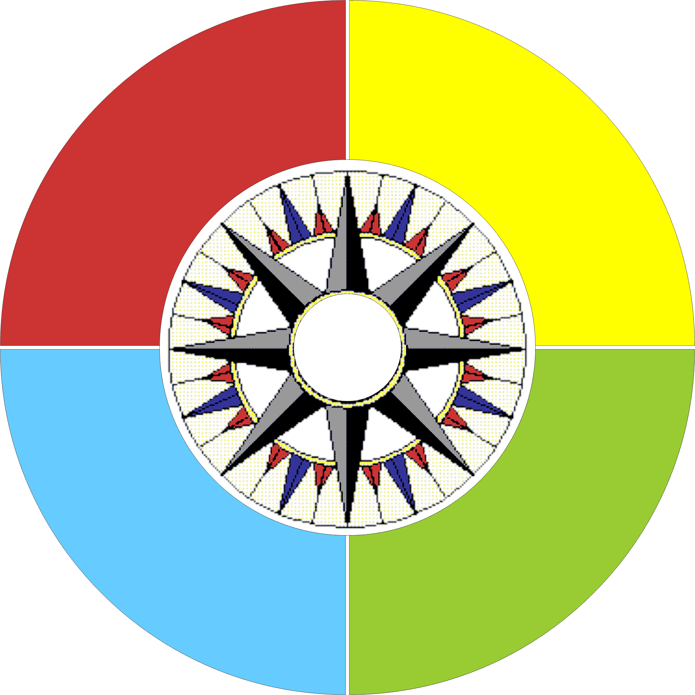    Planning & Goal-Setting  Implementation Processes  Monitoring & Reflection  Quality  Improvement  The symbol for Academic Systems & Processes (ASP) represents the stateroom compass or nautical compass – a compass that floats on gimbals to ensure stability. The central character or pointer is represented by the “Strategic Plan symbol” which establishes our current direction. The “compass rose” or middle tier identifies potential opportunities for Academic Systems & Processes, and illustrates the multiple initiatives. The outer gimbals are defined by the classic quality assurance cycle (Plan, Do, Check, Act) as defined by W. Edwards Deming and others. Working together and in alignment, the three elements provide direction and management of key activities and progress of the unit. | These three elements of the ASP work in concert to establish direction and stability. Individually, each element has specific objectives and categories as described below.
Strategic Direction 1: Learning
Learning Goals
- Program Portfolio
- Pathways
- Flexibility
- Inclusion
- Student Life

Academic Systems & Processes
Key Categories
- Program Development & Innovation
- Research & Communication
- Collaboration & Growth
- Governance & Accountability
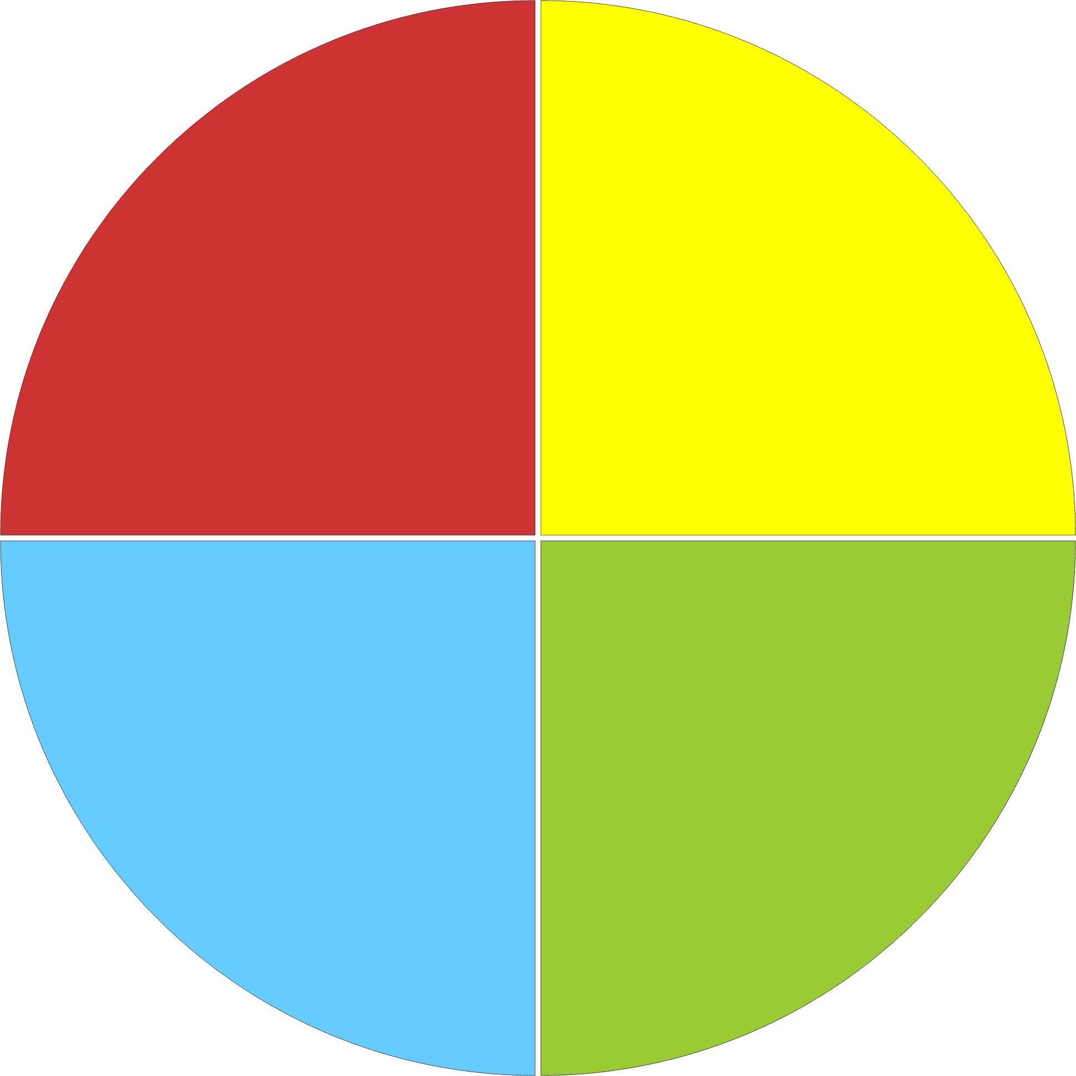Quality Assurance Cycle
Quality Steps
- Planning & Goal Setting
- Implementation Processes
- Monitoring & Reflection
- (Continuous) Quality Improvement

Overview of Academic Systems & Processes

A variety of activities go into the ongoing research, development, implementation, quality review and renewal of the College’s academic programs. These activities include:

Program Development & Innovation
      - New Program Research & Development
      - Program Review & Renewal
      - Curriculum Design & Development
      - Program Delivery Models/Options
      - Academic Systems & Applications
Research & Communication
      - Student Feedback, Program Portfolio & Report Cards
      - PeopleSoft Catalog & Advisement
      - Calendar Development & Communication
      - Curriculum Distribution Processes
Collaboration & Growth
      - Program Consultation (Faculty Working Groups, Course Development Teams, Dean’s Advisory Councils & Program Advisory Committees)
      - Professional Development Activities
Governance & Accountability
      - Quality Criteria & Reporting Mechanisms
      - Academic Plan
      - School Plans

- New Program Research & Development
New program ideas are received from various internal and external sources. The new idea is reviewed by the applicable academic School who decides whether to move the program idea to the Academic Systems & Processes team for future research. The new program idea moves through various phases of review, from School staff input into needs and feasibility study for briefing notes to approval by Deans’ Council, Executive Team, Board of Governors Programs Committee and Board of Governors to Department of Education. Following approval of the Board of Governors, curriculum development prepares the program for campus or alternate delivery.

- Program Review & Renewal
Every College program is placed on a rotating, five-year renewal cycle. In September, the Board of Governors’ Programs Committee is informed of programs being reviewed in the current year. An annual activities summary is prepared for the June Programs Committee. The five-year renewal process includes reviewing enrollment statistics, Key Performance Indicators (KPIs), program report cards, student feedback, employment statistics, industry input and other information that may lead to minor curriculum enhancements or actions such as intake suspensions if warranted. In addition, an annual review of program delivery, from each campus, is undertaken by faculty and Academic Chairs in consultation with the applicable School Dean.

- Curriculum Design & Development
Curriculum is developed, using an outcomes-based model, and is reviewed on a yearly basis by Faculty Working Groups, Curriculum Consultants and other Academic Program Development Teams. Academic Systems & Processes works to ensure consistency in format and quality of curriculum across the College through workshops and development of standard curriculum document templates.

- Program Delivery Models/Options
The majority of College courses/programs have been delivered utilizing the traditional face-to-face model. However, over the past five years, several programs have been “unbundled” and these programs are offered via alternate delivery (online, blended and workshops) during the day, evening and on weekends—meeting learners where they are. Prior Learning Assessment (PLA) assist the College to better serve learners, especially those presently in the workforce. Curriculum development includes identifying the best mode of delivery for courses within each program; thus, increasing our part-time offerings (through alternate delivery) for all Schools.

- Academic Systems & Applications
By the end of 2006-07, plans are to have all curricula housed in a common curriculum repository, or curriculum database. Starting in Fall 2006, all course outlines have a common look for the benefit of faculty and students and will be archived in a central location on the College’s SharePoint Portal. Academic Systems & Processes evaluates and tests supporting systems, applications and platforms – like the Curriculum Database, Collaboration Tools, and Web Calendar Content Management System – that support such initiatives.

- Student Feedback, Program Portfolio & Report Cards
As part of the Quality Assurance Process, Academic Services must regularly review student feedback through ongoing feedback such as the annual online feedback, as well as from larger Institutional Research initiatives such as the Graduate Follow-up Study. Institutional Research returns valuable statistical information to the Renewal Process in the form of Program Report Cards, which track program performance against targets. Academic Systems & Processes, through its development of guidance such as the Program Renewal Framework will help to define the kinds of data useful to ongoing quality assurance.

- PeopleSoft Catalog & Advisement
Course data is managed in the PeopleSoft course catalog which directly impacts class scheduling and student records. This centralized course catalog supports consistency of the course data across all Schools. Academic advisement rules for NSCC programs are also maintained in PeopleSoft. Like the course catalog, advisement rules are set up in a standard format to ensure consistency for our Academic Schools to enhance consultation with our learners.

- Calendar Development & Communication
A yearly schedule has been established for the development of the web- and print-based calendars. New programs, program name changes, program suspensions have to be made at least a year in advance in order for the information to be reflected in the print calendar. All curriculum changes are made by end of March of each year for the upcoming academic year. Although the print version of our calendar will continue for the foreseeable future, the College’s online web calendar is the “official” source of calendar information and is updated on a daily basis. This provides students and potential students with the latest and most accurate program information.

- Curriculum Distribution Processes
Various milestone dates have been established as to when changes must be made by FWGs, PWGs, and CDTs to programs and courses to be offered in the next academic year. Once these changes have been made, the curriculum consultants and curriculum support specialists update the program curriculum documents and then post these to a common drive for access by various College stakeholders including faculty, academic chairs, campus registrars, team leads etc. Minor changes can be incorporated throughout the academic year, but controlled content data ensures integrity for program and course delivery across the College.

- Program Consultation Mechanisms
Faculty Working Groups (FWG), in conjunction with the AS&P, meet regularly to review Program Advisory Committee (PAC), Deans’ Advisory Council (DAC) and industry comments regarding evolving graduates profiles for each program area. Following these discussions, curriculum is updated to better meet the needs of employers. Academic Systems & Processes is responsible for developing the framework and schedules for the various input groups.

- Professional Development Activities
In addition to planning the academic development and technical development activities needed to build capacity within the unit, Academic Systems & Processes is responsible for training all new staff in the area of Program Development through delivery of the NS1016 Designing & Developing Programs Course of the College’s Community College Education Diploma Program (CCEDP).
- Quality Criteria & Reporting Mechanisms
Inputs to the quality cycle include student feedback forms, student focus groups, faculty and academic chair annual reviews, graduates surveys, and program report cards. These inputs inform other components of the systems and processes. In addition, as seen in the following graphic, Academic Systems & Processes undertakes a Continuous Quality Initiative reviewing all of the foregoing processes and receiving and evaluating “Suggestions for Academic Process Improvement” forms from various stakeholders.

- Academic & School Plans
School Plans/Portfolios and other indicators are compared to NSCC’s Balanced Scorecard and become part of the ongoing reporting mechanism and input to the Academic Plan.

All of these activities and processes are interrelated and essential to the successful design,
development and delivery of our programs. The final Academic Plan will provide annual and
multi-year workplans for each component.

Program Development Framework

To illustrate the work of the Academic Systems and Processes, the following pages describe the framework for quality assurance process that is embedded in the New Program Development and Program Review & Renewal processes. The graphic below shows the overall model or lifecycle for program development. The process is a continuous cycle that will ensure programs are regularly reviewed, renewed and evaluated for sustainability and contribution to NSCC’s Strategic and Academic Plans to meet the needs of the Province.
Identification
Identify
Quantify
Plan
Assessment
Collect
Analyse
Assess

Monitoring

Prepare
Deliver
Monitor
Reflect

Program Development Framework
Proposal
Prioritize
Resource
Initiate
Development
Redesign
Verify
Develop

Starting Point for New Programs
Starting Point for Program Renewal
Sample Process Framework (New Program Development)

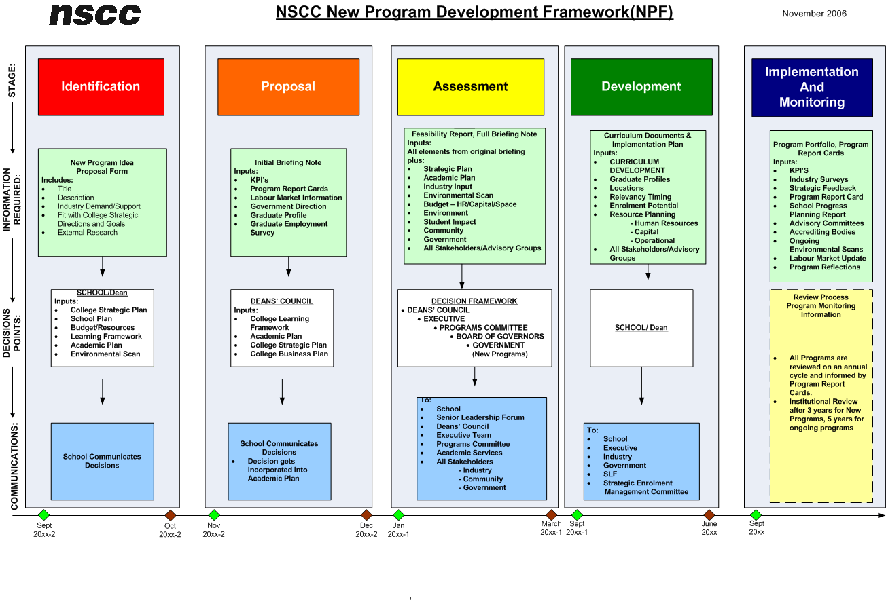

* Note the timeline at the bottom of the process chart, which describes the typical evolution of a new program idea from initial consideration by the schools, to the potential launch. The estimated incubation of a new program idea is approximately two years.
Sample Process Framework (Program Review and Renewal Framework)

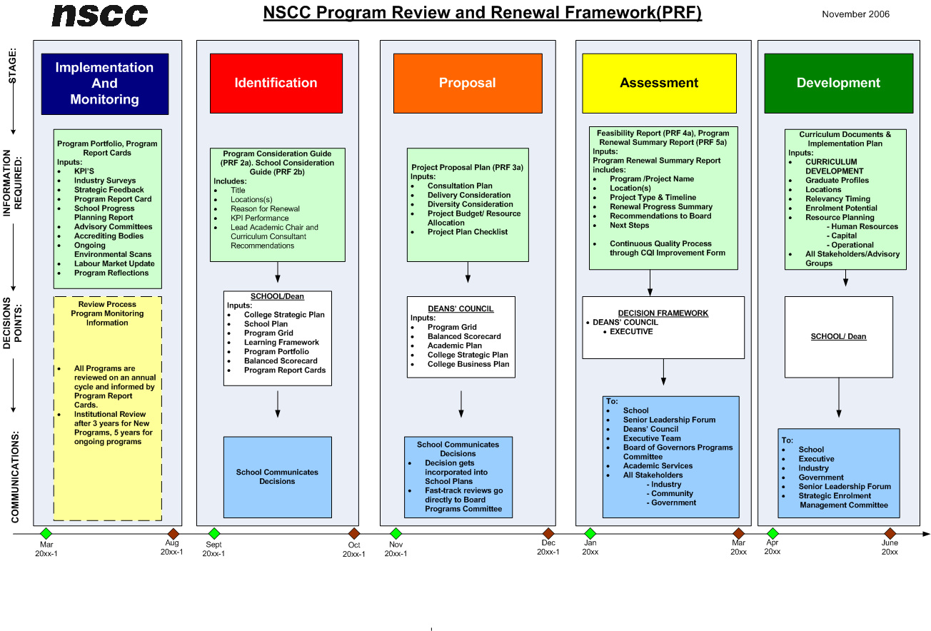
* Note the timeline at the bottom of the process chart, which describes the typical evolution of a program renewal from identification, to completion of curriculum re-development. The estimated timeline for a program going through a full renewal is approximately 15 months.
APPENDIX C
School Workplan – School of Applied Arts & New Media SAMPLE ONLY
Program Planning & Renewal Schedule 2006/07 – 2010/11: Existing Programs

PROGRAM CLUSTERS | Credential | Duration | 2006/07 | 2007/08 | 2008/09 | 2009/10 | 2010/11
Information & Computer Technologies
Computer Electronics Technician | Diploma | 2 year |  |  |  |  | review
Computer Network Technology | Adv. Diploma | 1 year |  |  |  | review
Computer Service Technician | Diploma | 2 year | review
Information Technology | Diploma | 2 year |  |  |  | review
- Year 1 – Common Year
- Year 2 – Web Development
- Year 2 – Database Management
- Year 2 – Programming
- Year 2 – Systems Management./Networking
Applied Communication & Visual Arts
American Sign Language/English Interpretation | Diploma | 2 year | review
Applied Communication Arts | Certificate | 1 year |  |  |  | review
Deaf Studies NEW | Certificate | 1 year | Development | New |  |  | review
Digital Animation | Diploma | 2 year |  |  |  |  | review
Graphic Design | Diploma | 1 year |  |  |  | review
New Media Design & Development | Diploma | 2 year | Suspended | Delete
Interactive & Motion Graphics NEW | Diploma | 2 year | Development | New |  |  | review
Music Arts & Business NEW | Diploma | 2 year | Development | New |  |  | review
The Art of the Music Business NEW | Certificate | 1 year | Development | New |  |  | review
Photography NEW | Diploma | 2 year | New |  |  | review
Photography II/Digital Imaging | Adv. Diploma | 1 year | Delete
Printing & Digital Technology | Diploma | 2 year | Modify-Expand |  |  | review
Graphic & Print Production NEW | Diploma | 2 year |  | New |  |  | review
Radio & Television Arts | Diploma | 2 year |  | review
- Year 1
- Year 2 – Broadcast Journalism
- Year 2 – Radio Performance & Audio Production
- Year 2 – Television Production
Recording Arts | Certificate | 1 year |  | review
Screen Arts | Diploma | 2 year |  | review
PROGRAM CLUSTERS | Credential | Duration | 2006/07 | 2007/08 | 2008/09 | 2009/10 | 2010/11
Geomatics
Applied Geomatics Research | Adv. Diploma | 1 year |  |  | review
Cartography – Digital Mapping | Diploma | 2 year | review
Geographic Information Systems | Adv. Diploma | 1 year | review
Geographic Information Systems Technician | Certificate | 1 year |  |  | review
Geographic Information Systems for Business | Adv. Diploma | 1 year | review
Geomatics Engineering Technology | Diploma | 2 year |  |  |  |  | review
Geomatics Programming NEW | Adv. Diploma | 1 year | New |  |  | review
Marine Geomatics | Adv. Diploma | 1 year |  | review
Planning: Land Information Technology | Diploma | 2 year |  |  |  |  | review
Remote Sensing | Adv. Diploma | 1 year | review
Survey Technician | Certificate | 1 year |  |  |  | review
Joint Masters in Applied Geomatics NEW | Adv. Dip./ Deg. | 1 year | New |  |  | review

Glossary of Terms

Term | Definition
Academic Systems & Processes (ASP) | This internal unit at Academic Services is made up of curriculum consultants, curriculum support specialists, researchers, and project teams who research, test, evaluate and recommend academic systems, processes, and procedures to the Deans’ Council and VP Academic/Chief Learning Officer.
Board of Governors Programs Committee | The Programs Committee receives and comments on New Program Proposals and Program Review & Renewal Reports on behalf of the NSCC Board of Governors.
Deans’ Council | This academic group consists of the Deans of each of the five Schools, Dean of Organizational Learning, Dean of Business Development and key academic leaders of the institution including the Associate VP Learner Development & Pathways, College Registrar, Director of Library Services & Online Learning. Deans’ Council makes strategic and operational decisions on Academic Development and Delivery and guides the activities of the Academic Systems & Processes team.
Key Performance Indicators (KPIs) | The Key Performance Indicators (KPIs) are a set of quantitative objectives derived from the College’s Balanced Scorecard. For Academic Services the KPIs include target measures of enrolment, student retention, student satisfaction, diversity, and sustainability.
Program Report Cards | Produced annually (or more often as required) Program Report Cards are generated by NSCC Institutional Research and compares KPIs for a specific program to cluster and college-wide performance.
Curriculum Documents | Curriculum Documents are expository descriptions maintained by Academic Systems & Processes for every core program and course in the college. ASP develops standards and templates for the production of these critical documents.
Faculty Working Groups (FWGs) | Faculty at NSCC engage in program and course development activities through the efforts of Faculty Working Groups. Program-level working groups (PDTs) plan program structure and sequencing, while course-level teams (CDTs) work to develop robust curriculum including course outcomes and teaching methodologies.
Prior Learning Assessment (PLA) | Fundamental to the Portfolio Learning approach at NSCC, PLA is a set of guides and processes to help articulate the learning of students, particularly that learning which may have been achieved in non-academic or non-NSCC learning environments.
Curriculum Consultant (CC) | Each School at NSCC has one or more Curriculum Consultants assigned to assist the School in a particular occupational cluster. The CC provides academic research, planning, and process support to the School.
Curriculum Support Specialist (CSS) | In addition to overall administrative support, Curriculum Support Specialists maintain and develop critical documentation, data, and systems in support of Academic Systems & Processes.
Curriculum Database | A new data warehouse connected to the College’s Learning Management System, provides a controlled environment for housing, archiving, and managing academic content. This system will eventually provide strong integrity between curriculum, calendar and the PeopleSoft Catalogue.
Web Calendar Content Management System | The Web Calendar visible on the College’s website, is driven by a database system that derives information from the PeopleSoft Course Catalogue, Advisement Module and a management interface accessible to members of Academic Systems & Processes.
SharePoint Collaboration Tools | Academic Systems & Processes manages curriculum distribution and intra unit collaborative activities with the support of the College’s collaborative web application, SharePoint Team Services. Eventually the unit expects to use SharePoint’s College Portal (OurNSCC) to distribute curriculum and to publish key process documents.
New Program Development Framework (NPF) | This process framework provides guidance to the development of procedures and documentation for New Program approval and development (please see the attached chart).
Program Review & Renewal Framework (PRF) | This process framework provides guidance to the development of procedures and documentation for formal Program review and renewal (please see the attached chart). Program reviews are required after three years for a new program and every five years for ongoing programs.
Deans’ Advisory Councils (DACs) | Deans’ Advisory Councils are made up of strategic industry leaders, school leadership, faculty and students who come together to discuss strategic and evolutionary issues in broad occupational areas.
PeopleSoft ERP | PeopleSoft is the software NSCC uses to help us manage Finance, Human Resources / Payroll and Student Administration. It is the enterprise solution for NSCC.
Program Advisory Committees (PACs) | Program Advisory Committees are a group of experts in a specific program or occupational area who help define and articulate the working skills and attributes required for a program graduate.
Graduate Follow-Up Study | This research study, conducted by NSCCs Institutional Research Division, provides critical feedback on the College and its programs by graduates of NSCC.
Community College Education Diploma Program (CCEDP) | All new faculty and professional support staff at NSCC are required to complete the College’s internal Academic Training program, the Community College Education Diploma Program, a series of courses designed to help train skilled practitioners into effective adult learning facilitators and professionals within a learning-centered college.
NSCC Balanced Score Card | A balanced scorecard is a mechanism that helps an organization balance focus between four critical areas of strategic performance. In the case of NSCC, the four areas are Financial, Provincial Impact, Learning Outcomes, and Learning & Growth.
Learning Leadership Forum (LLF) | LLF is a think-tank and collaboration of academic development/delivery leaders in the College. The group includes Academic Chairs; Managers associated with Academic Planning, Apprenticeship, Online Learning and Organizational Learning; Curriculum Consultants and Support Specialists; Campus Team Leads and Regional Librarians. The focus is on the development and management of effective learning environments at NSCC.
Senior Leadership Forum (SLF) | SLF is a collaboration of Senior Academic Management of the College including the Executive Team, Deans, Principals and Directors. The activities of the SLF include discussion and presentations on strategic leadership relating to provincial, national and global trends.

